Diamond Club Reserve
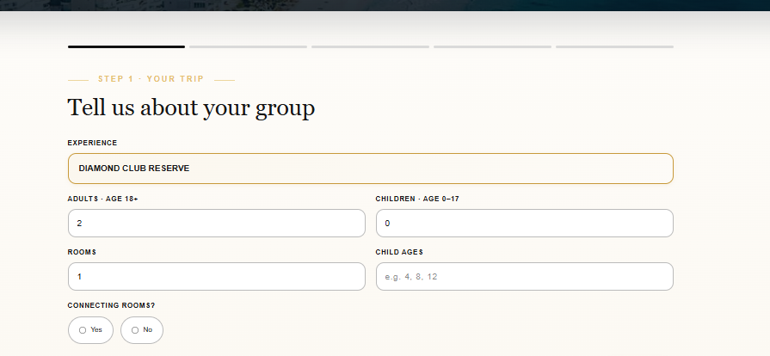
Diamond club reserve at kanai

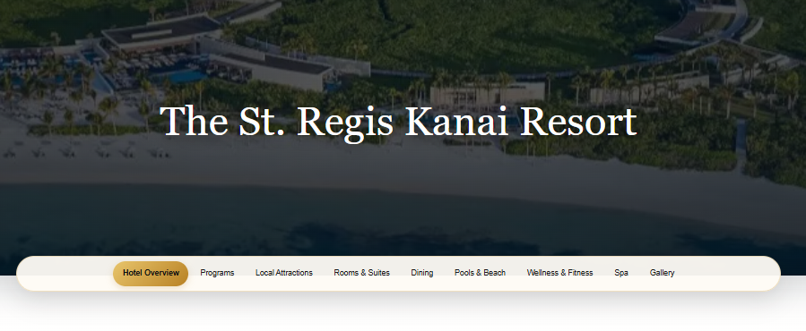
brochure also here
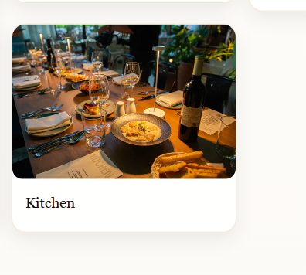
Take it off

New box Grand ballroom

### Grand Ballroom – Yom Tov Dining
Celebrate Yom Tov in the elegant Grand Ballroom, transformed into a beautiful dining setting for our festive holiday meals. Enjoy exceptional gourmet cuisine, attentive service, and a warm, inviting atmosphere as family and friends gather to celebrate together.

Pic for the Grand ballroom

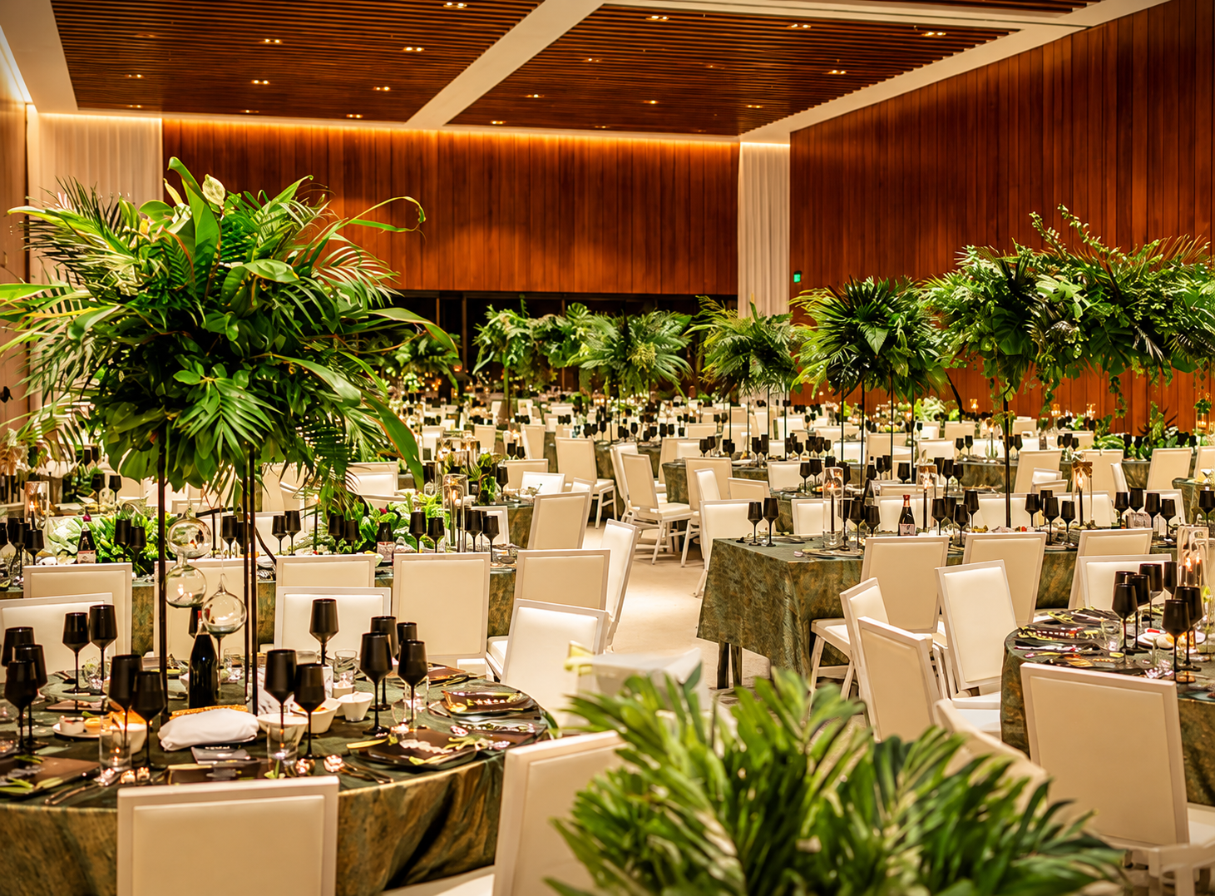

New BOX Grand Ballroom – Shabbat & Yom Tov Kiddushim

### Grand Ballroom – Shabbat & Yom Tov Kiddushim
Experience our lavish Shabbat and Yom Tov Kiddushim, featuring an impressive selection of gourmet specialties, traditional favorites, premium wines, and beautifully presented delicacies. A wonderful opportunity to gather, socialize, and celebrate in an elegant and festive atmosphere.

Pic for the Grand ballroom Kiddushim

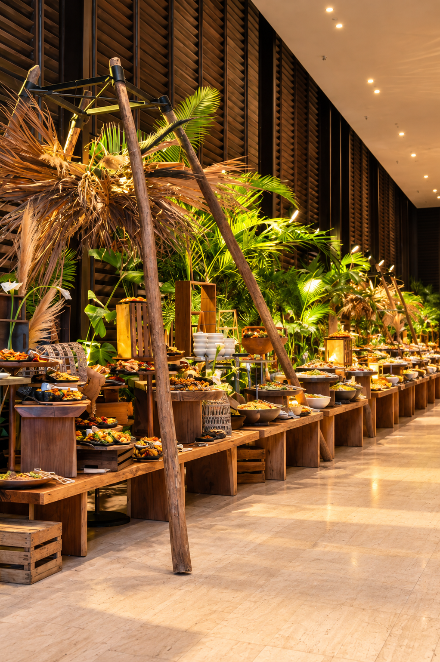
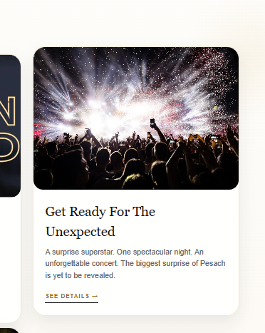

Please put in the artist photo below

BEN TZUR – LIVE IN CONCERT
### ISRAEL'S BREAKOUT SUPERSTAR OF 2026

Get ready for an extraordinary night as *Ben Tzur, one of Israel's hottest and most celebrated musical sensations,* takes center stage for an unforgettable live concert!

Following a phenomenal year of chart-topping hits, sold-out performances, and a meteoric rise to stardom, Ben Tzur has become one of the most exciting names in Israeli music. With smash hits including *"Ahavat Hashem," "Ish HaPele," "Kol Akava Letova," "Abba," and "Neshamot Tzmeot,"* his music has captured the hearts of millions.

Fresh off spectacular performances at Israel's most prestigious concert venues, Ben Tzur brings his unmistakable voice, incredible stage presence, and electrifying energy to an exclusive Diamond Club Vacations performance.

Prepare for a breathtaking evening featuring a full live band, dazzling stage production, powerful melodies, and the biggest hits that have taken Israel by storm.

*One of Israel's biggest stars. The hits everyone is singing. One spectacular night.*

This Passover, experience the superstar sensation of Ben Tzur LIVE — an extraordinary musical celebration and one of the crown jewels of our 2027 entertainment lineup!

### So'ol Beach Club
Enjoy relaxed beachfront dining with refreshing flavors, light bites, and tropical favorites, all served in a beautiful setting overlooking the Caribbean Sea.

### Galato
A delightful destination for refreshing frozen treats, delicious ice cream, and sweet indulgences, perfect for a relaxing afternoon under the Riviera Maya sun.

### KIIS
An elegant dining experience featuring beautifully prepared dishes, creative flavors, and a sophisticated atmosphere designed for memorable evenings.

### Oceana Fish & Chips
Enjoy fresh seafood favorites, crispy fish and chips, and delicious coastal-inspired dishes in a vibrant, open-air tropical setting.

### Lobby Bar
A sophisticated gathering place offering handcrafted cocktails, premium beverages, and a relaxed atmosphere to unwind and socialize.

### PIZZO
A casual and inviting dining destination serving freshly prepared pizza, flavorful specialties, and delicious bites in a lively outdoor atmosphere.

### Kitchen
Start every morning with a lavish breakfast featuring freshly prepared favorites and an extensive selection of gourmet offerings. During Chol Hamoed, return for an exceptional dinner experience showcasing our signature culinary creations.

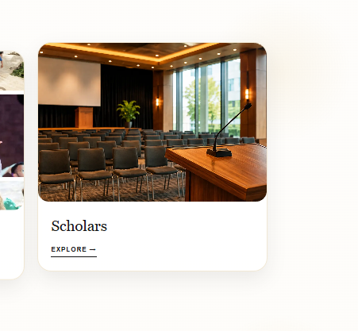

Scholars & Cantor

Add a box

Experience the extraordinary voice of *Cantor Nissim Saal*, one of the most captivating and celebrated voices in contemporary cantorial music.

Renowned for his breathtaking vocal range, heartfelt melodies, and commanding presence, Nissim brings unparalleled beauty and emotion to every prayer.

His magnificent renditions of traditional liturgy create an uplifting and deeply moving atmosphere, enriching the spirit of Shabbat and Yom Tov.

*A world-class chazzan whose powerful voice and inspiring tefillot promise a truly unforgettable Yom Tov experience.*

